Setup manual for

Standard Excel file

*by Mariusz Malinka*

ICE

Table of Contents

I. What is a *Standard Excel file*? 3

II. Sample file and template 3

III. Creating a new *Standard Excel file* 4

IV. Rows and their intended use 5

V. Columns and their intended use 6

VI. File implementation 7

# What is a *Standard Excel file*?

*Standard Excel file* is a Microsoft Excel Worksheet with a very specific format. It is used by *ICE* to import data for further analysis. Columns and rows have strictly defined roles and should contain data according to *Standard.* It is vital that in order to import data into *ICE* each row and column **must be filled** with data, the software does not support importing from an Excel file with missing values. A sample file properly formatted can be found in the GitHub software repository and can be used as a template.

|  |
| --- |
| *IMPORTANT* |
| When using *ICE*, you can import data from an Excel file only if it has an **.xlsx** extension. To use a file with a different extension, open it in Excel or another program and save it as file with **.xlsx** extension. |

# II. Sample file and template

To get started, you can download the sample file or template of *Standard Excel file* from software GitHub repository by following instructions below.

1. Launch your browser and enter link [*https://github.com/MariuszMalinka/ICE*](https://github.com/MariuszMalinka/ICE)into address bar.

A GitHub repository will appear on your screen. In the central frame, you can access any file of the software. Among those files there is a *documentation* folder containing sub folders for every major software version.

1. Click on the name of *documentation* folder.
2. Click on the folder named after your software version.
3. Choose files you are interested in and click on the  button.

# III. Creating a new *Standard Excel file*

The *ICE* can operate on files regardless of the number of columns, but due to expectation of our customers the *Standard Excel file* format was created. It is composed of one header row, two columns containing date and time, one column made of optimal values for the given input values, five columns made with input values and the last one with comments not interpreted by the software.

To illustrate the appearance of the *Standard Excel file* format, the columns and rows are highlighted in the document with colors as follows:

|  |  |  |  |  |  |
| --- | --- | --- | --- | --- | --- |
| Red | Orange | Yellow | Green | Light green | Blue |
| Header | Date | Time | Optimal value | Input value | Comments |

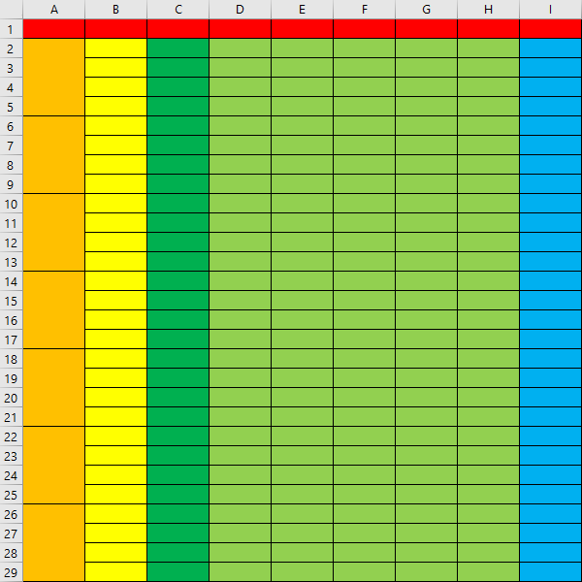

*Standard Excel file template with colors*

# IV. Rows and their intended use

In the *Standard* format we can distinguish two main types of rows. The first one is header and the second one is row with values.

|  |  |
| --- | --- |
| **Header** | The first row of Excel is reserved for column names. Column names are important for the user interface. These names are called by the software to request the user to enter input values. The headings are not mandatory to enter, but their comprehensive description makes everything much clearer. Example header names are day, hour, optimal value, input values (5 columns) and comments. |
| **Row with values** | Each row after the header is interpreted by *ICE* as a row containing values used to build the mathematical model. The cells in these rows contain data of a specific type depending on which column they are in. The *ICE* software does not specify a maximum number of rows, it will build a model using each row containing data. |

|  |
| --- |
| *NOTE* |
| The latest software version does not allow importing files with incomplete data. In case there is empty row, it should be removed from the file. This may be changed in future versions. |

# V. Columns and their intended use

In the *Standard* format we can distinguish five types of columns. Only two of them are used to create mathematical model.

|  |  |
| --- | --- |
| **Date** | The column named Date can contain days of week and dates in the Long Date format of an Excel cell. At the moment, this column is not interpreted by the *ICE* software. This functionality will appear in a future version. |
| **Time** | The Time column indicates exact time when the data was collected. Those cells are in Excel Time format. At the moment, this column is not interpreted by the *ICE* software. This functionality will appear in a future version. |
| **Optimal value** | The Optimal value column is reserved for values that are assumed to be the ideal output values for given input values. Correctly assuming the optimal value is the key to getting the most accurate final values from *ICE*. The values in this column are crucial to the proper operation of the software. |
| **Input values** | In the *Standard* there are five columns reserved for input values. They are not required to be filled in all, but empty columns must be filled with zeros for the program to work properly. The names of columns containing input values are called by the software to request the user to enter those values. |
| **Comments** | This column will never be interpreted by *ICE* software. Its purpose is to contain explanation of any unexpected occurrence in data. |

# VI. File implementation

Once you have configured your file, you can compare it with the sample file shown below. If everything looks similar, you can run *ICE* software and apply your file. For additional information please reach out to the *Help* documentation.

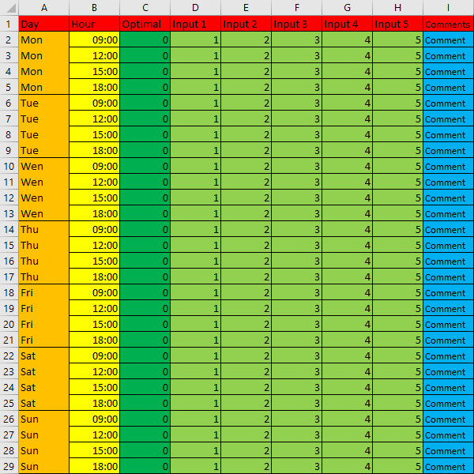

*Example file configuration.*